Stephanie Ann Bio

Stephanie Ann is a Stick of Dynamite that Explodes on Stage! She is not your typical cookie-cutter entertainer. That's why she is becoming one of the hottest and most sought after entertainers in the US today.

Born and raised in Brandon, Florida, Stephanie Ann began singing at a very early age. "She even broke her crib one day while singing and jumping up and down. She was always singing," her mother recalls. She then began playing the violin and got hooked on the classics playing Bach, Mozart & Beethoven.

"I would practice for hours on the violin playing all this classical music, and then I'd turn the radio on and start jamming to Charlie Daniels. It was pretty wild." Stephanie Ann received a bachelor's degree in classical violin and voice from the prestigious Peabody Conservatory of Music in Baltimore, Maryland. Upon receiving a full-tuition scholarship from the University of North Texas, she later earned a masters degree in violin and music education.

"I was fortunate to get a good solid musical education. But I always knew that instead of playing for the New York Philharmonic, or being an opera diva, I was going to write my own songs and sing and play in my own band."

Stephanie Ann performed with such artists as Tony Bennett, Dionne Warwick, Smokey Robinson and Marvin Hamlisch, as well as touring all over the country and playing on the Grand Ole Opry in Nashville, Tennessee with Country Music Legend Bill Anderson. Singing and playing with these artists gave her the incentive to take the Stephanie Ann Show on the road.

Her budding performance career is now a result of that incentive. Stephanie Ann's debut CD entitled "A Little Fiddle Action" not only highlights her virtuosity on the violin/fiddle, but makes it clear that she can write a song just as well as she can sing one. Her lyrics are reflective and her melodies make up a unique blend of pop, gospel, jazz & country music.

Besides receiving standing ovations for her energetic and spontaneous performances all over the United States, she has performed sold out shows in Europe & Canada. Stephanie Ann’s second CD entitled "Here I Am" in which she wrote 9 of 10 songs, has received much radio airplay. Instrumental Favorites, her third CD is her # 1 best selling CD and her 4th, To Life, has just been released to rave reviews from fans across the country.

Stephanie Ann Show!
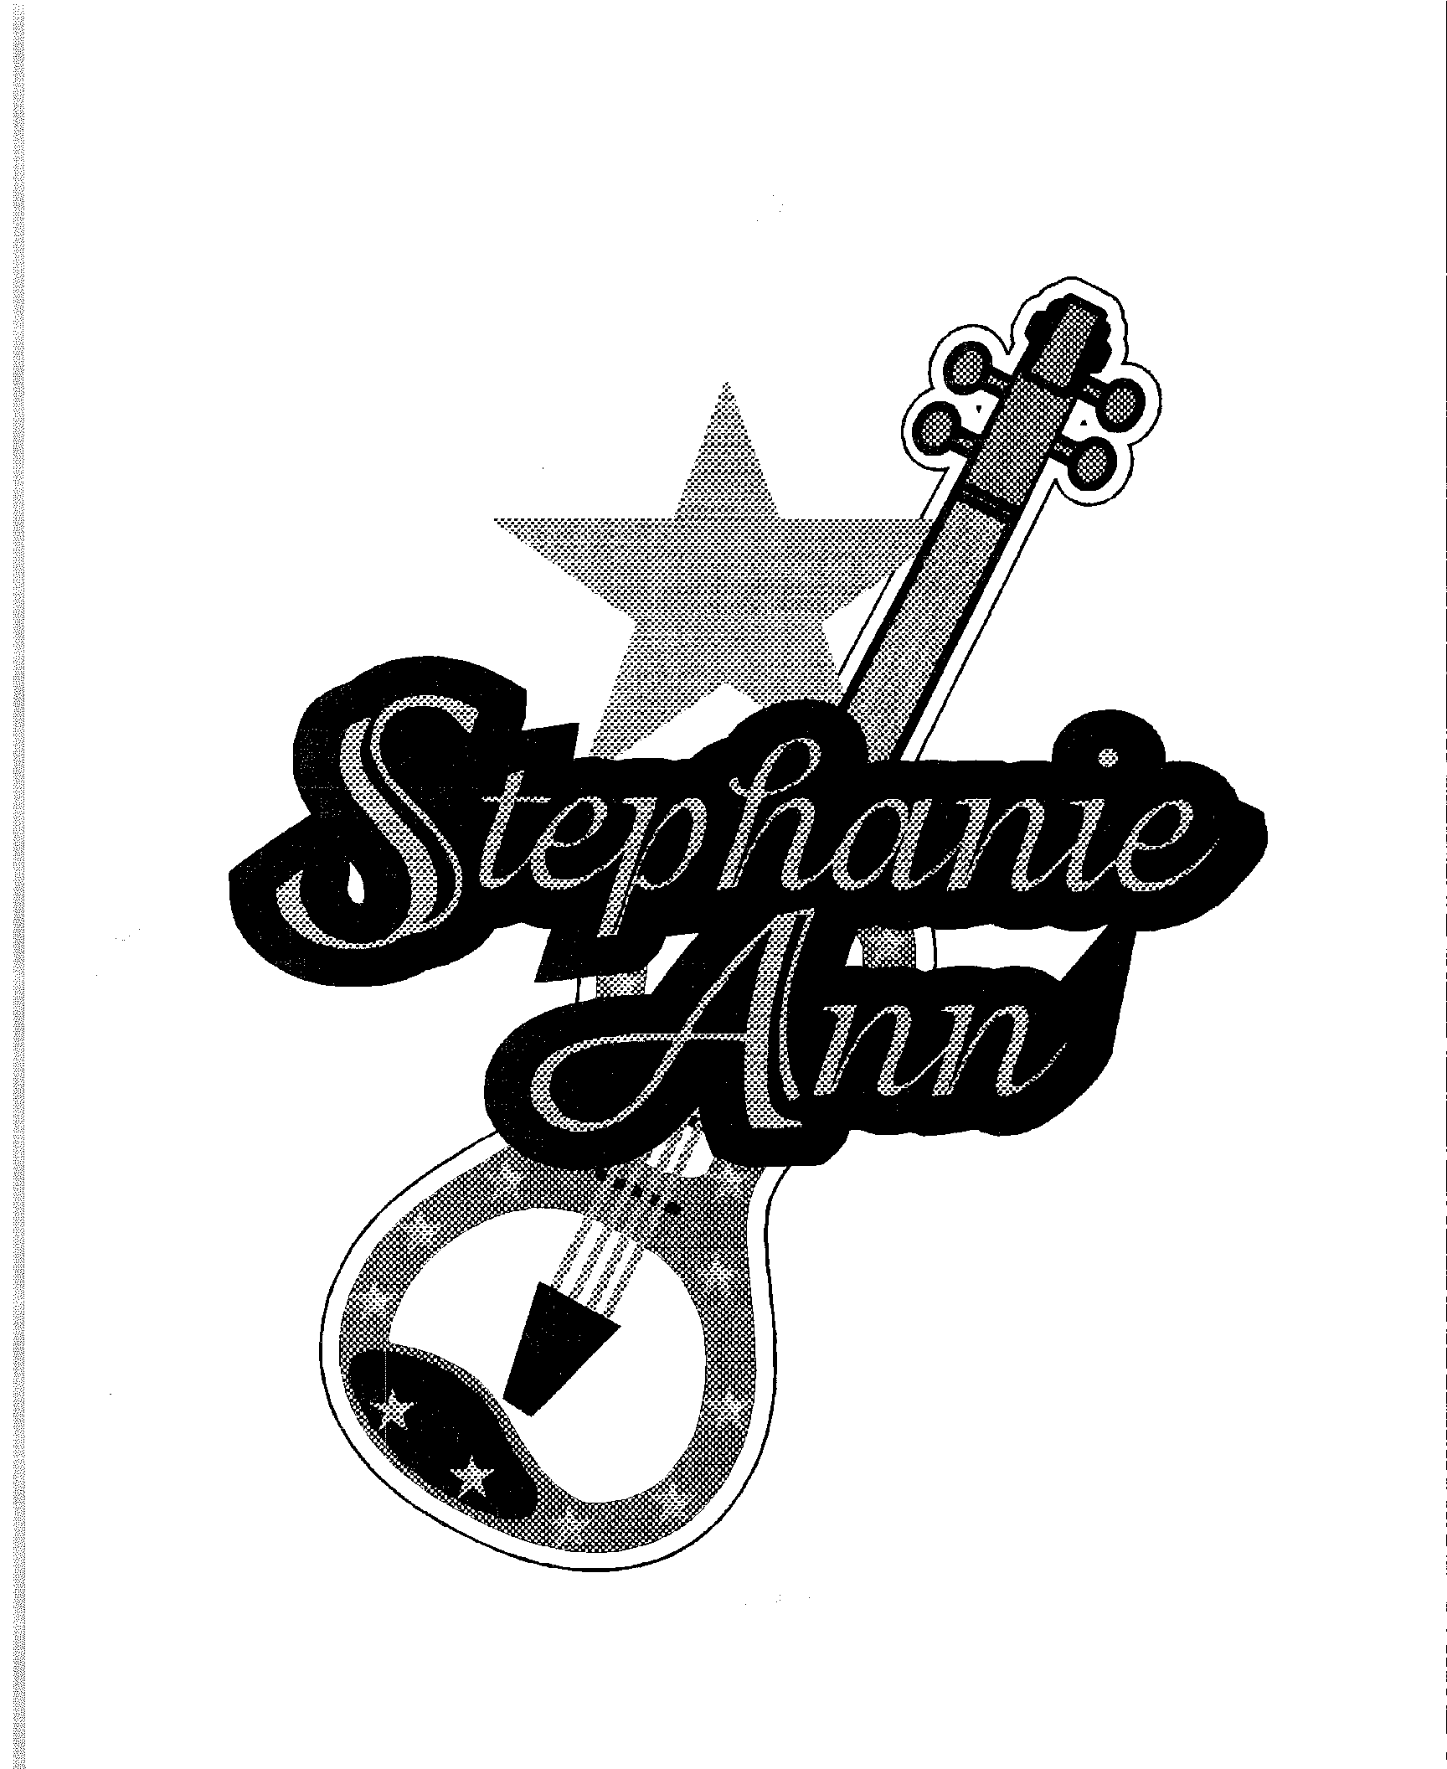

TESTIMONIALS

“Stephanie Ann is an accomplished performer that delivers a high energy show enthusiastically received by the audience”.
----Dave Fleming - Port Orange Amphitheater, Port Orange, FL

“A dedicated, Top-Flight performer who works very hard at her craft. She is a GIFTED TALENT and is vibrant, ENTHUSIASTIC and sincere.”
----Ron Beckey - North Florida Event Planner, Tallahassee, FL

“We at the Cabarrus County Fair highly recommend the Stephanie Ann Show...It’s FANTASTIC! She radiates PERFECTION... in every performance, with her enthusiasm, energy and abundant talent.”
----Mary Ann Hammill - Cabarrus County Fair, Concord, NC

“Stephanie Ann is a STAR waiting to be discovered - book her while you still can - with her talent & faith, we may all soon be able to say ‘we knew her when!’”
----Brenda Richards - Entertainment Buyer - Reflections on Silver Lake, Avon Park, FL

“Stephanie Ann is a VERY TALENTED artist with a BRIGHT FUTURE. I would recommend her to any fair, festival or special event looking for a high-energy act”
----Ann Deen - Florida State Fair, Tampa, FL

“Stephanie Ann is a REAL CROWD PLEASER! If you are looking for talent to entertain people of all ages, you definitely want to book Stephanie Ann.”
----Sally Griffis - Entertainment Buyer, Jackson, MI

“A real crowd pleaser with HIGH ENERGY and a good cross section of pleasing the wide audience age range.”
----Greg Pool - Event Planner, Melvin, IL

“The Citrus County Fair entertainment committee & the Fair Board of Directors was very pleased to have Stephanie Ann as part of our Show. She is a crowd pleaser and very easy to work with. We will have her again”.
----Jean Grant - Citrus County Fair, Inverness, FL

“She is a great inspiration for young people. I enjoyed the way she talked “to” the audience, not “at” the audience”.
----Marie Crader - Cheyenne Civic Center/Christmas Parade, Cheyenne, WY

“I would highly recommend the Stephanie Ann Show to any Exhibition wanting a HIGH-QUALITY, high-energy show!”
----Randy MacDonald - Royal Manitoba Winter Exhibition, Brandon, Manitoba, Canada

Talent Buyer Show Survey Results
(On a scale of 1 to 10, where 1 is poor/low and 10 is excellent/high)

Average Overall Performance Level 9.82 out of 10
Average Audience Satisfaction Level 9.82 out of 10

Latest News Article

